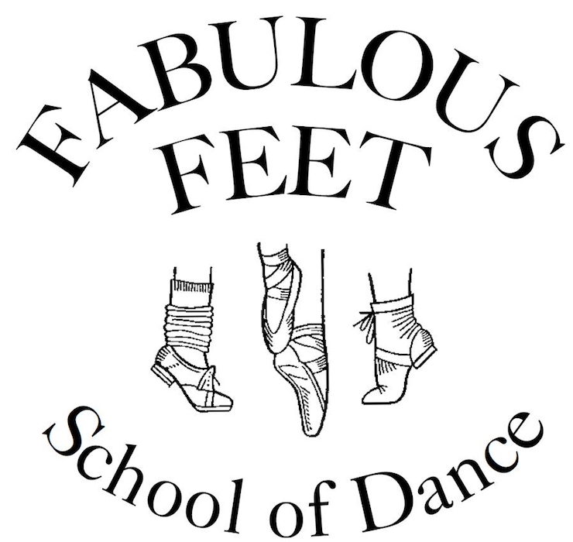
#3-22826 Dewdney Trunk Road,
Maple Ridge, BC V2X 7Y3
604-467-9846
fabulousfeet@telus.net
www.fabulousfeet.ca

CALENDAR 2020/2021 Important Dates

We follow the SD#42 calendar for school closures and snow days

Sept 14, 2020 First day of classes
Sept 28, 2020 Pro-D for schools – dance in session
Oct 1, 2020 All Costume & Competition Fees Due
Oct 12, 2020 CLOSED – Thanksgiving Day
Oct 23, 2020 Pro-D for schools – dance in session
Oct 26 – 31, 2020 Studio Spirit Week – Wear your Halloween costumes to dance
Nov 11, 2020 CLOSED – Remembrance Day
Nov 12, 2020 Pro-D for schools – dance in session
Dec 14 – 19, 2020 Studio Spirit Week – Wear your Pajamas to dance
Dec 19, 2020 CLOSED for Winter Break
Jan 4, 2021 Classes back in session
Jan 25, 2021 Pro-D for schools – dance in session
Feb 8 – 13, 2021 Studio Spirit Week – Wear Pink or Red for Valentines to dance
Feb 15, 2021 CLOSED – Family Day
Feb 16, 2021 Pro-D for schools – dance in session
Feb 20, 2021 Solo-Duo Show 9:30am / Competitive Group Showcase 1:00pm – ACT Theatre
Mar 15-20, 2021 CLOSED – Spring Break (only closed first week)
Mar 22, 2021 Classes back in session
Apr 2-5, 2021 CLOSED – Easter Weekend (Fri, Sat & Mon)
Apr 8-11, 2021 View Dance Challenge – Vancouver
Apr 21-25, 2021 Shine Dance Festival – Clarke Theatre, Mission
Apr 29-May 2, 2021 View Dance Challenge – Whistler (Company Classes)
TBD Photo Days (At the dance studio) Studio is closed for Saturday classes
May 12, 2021 Pro-D for Schools – dance in session
May 22-24, 2021 CLOSED – Victoria Day Weekend (Sat & Mon)
TBA In-House Registration for September
June 10, 2021 Dress Rehearsal – ACT Theatre (approx.3:00pm on) Studio is closed for classes
TBA Open Registration for September (New to Fabulous Feet)
June 22, 2021 Last Day of Classes
June 24, 25, 26, 2021 Year End Shows – ACT Theatre - Thur June 24 @ 6:30, Fri June 25 @ 6:30, Sat June 26 @ 1:00 & 6:30

